|  |  |  |  |  |  |  |
| --- | --- | --- | --- | --- | --- | --- |
| VILNIAUS KOLEGIJA  UNIVERSITY OF APPLIED SCIENCES  FACULTY OF ELECTRONICS AND INFORMATICS  Image result for viko logo | | |  | | | VILNIUS COLLEGE  Image result for viko logoFACULTY OF ELECTRONICS AND INFORMATICS |
|  | | |  | | |  |
| **SOFTWARE DEVELOPMENT MANAGEMENT** | | |  | | | **INTRODUCTION TO INFORMATICS** |
| PRACTICAL ASSIGNMENT  PROJECT WORK  6531BX028 PI18E | | |  | | | PRACTICAL ASSIGNMENT  SPOTIFY USER MANUAL  6531BX028 PI18E |
| STUDENT | DŽIUGAS PEČIULEVIČIUS  EDITA KOMAROVA | STUDENT | | DŽIUGAS PEČIULEVIČIUS |
| (SIGNATURE)  2/25/2021 | | |  | | | LECTURER |
| LECTURER | ASTA DANILEVIČIŪTĖ | (SIGNATURE)  10/17/2018 | | VIRGILIJUS KUKLIERIUS |
| (SIGNATURE)  2/25/2021 | | |  | | | 2018 |

2021

# PROJECT IDEA, GOAL AND SCOPE

## **Idea**

Project idea would be a clothing e-commerce shop.

## **Goal**

To create ecommerce website that provides clothes and quick & easy checkout for its clients

## **Scope**

* User should be able to login/register
* User should be allowed to order clothes.
* Browse products (clothes)
* Should be able to add products to cart and be able to pay for them
* Should be able to see order status.
* Should be able to checkout items with a credit card or PayPal.

## **Stakeholders**

* Project owner.
* Customers.
* Team members.
* Sellers.

## **Implementation location and time**

2021, Vilnius University of Applied Sciences, using virtual tools like MS Teams.

# PROJECT SCHEDULE AND BUDGET

## **Work breakdown structure (WBS)**

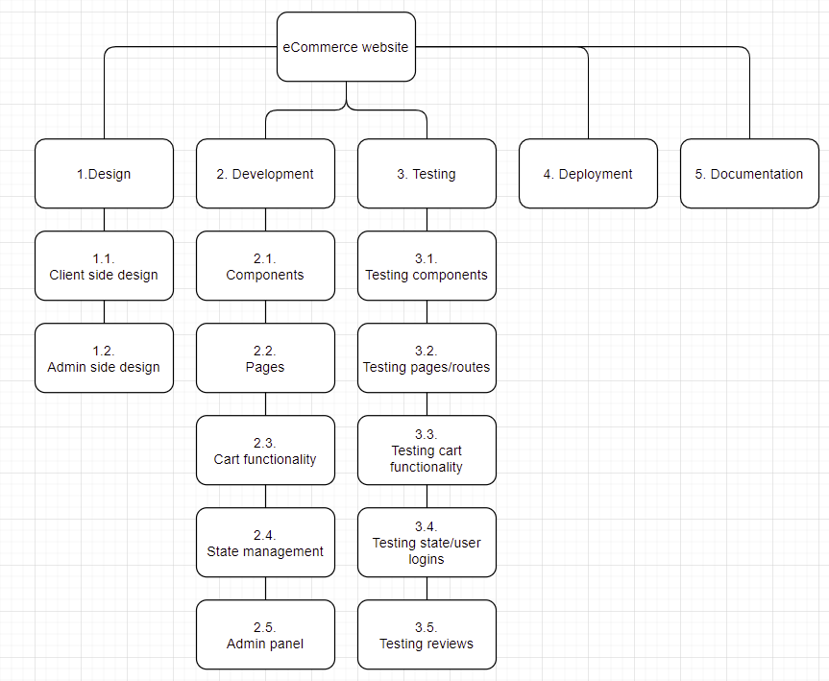

Figure 1 – WBS

## **Network Diagram**

## **Project tasks, their duration and dependencies**

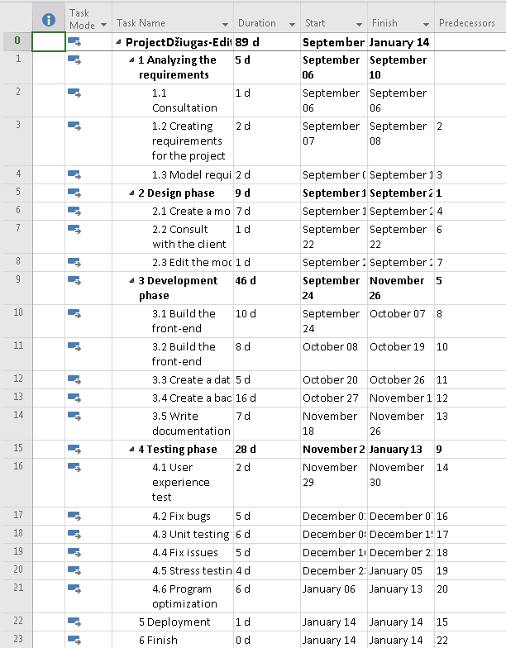

Figure 2 - Project tasks, their duration and dependencies

## **Material resources and their costs**

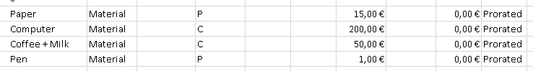

Figure 3 - Material resources

## **Human resources, payment rates and methods**

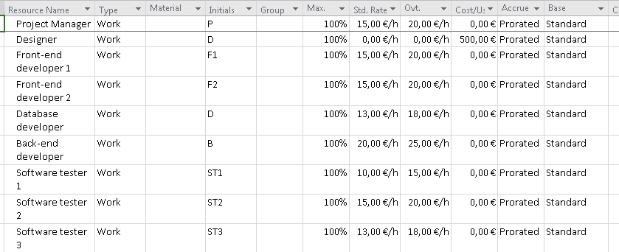

Figure 4 - Human resources

## **Fixed costs**

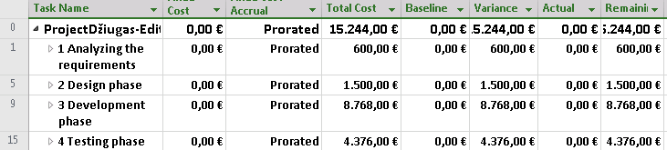

## **Resources assigned to project tasks**

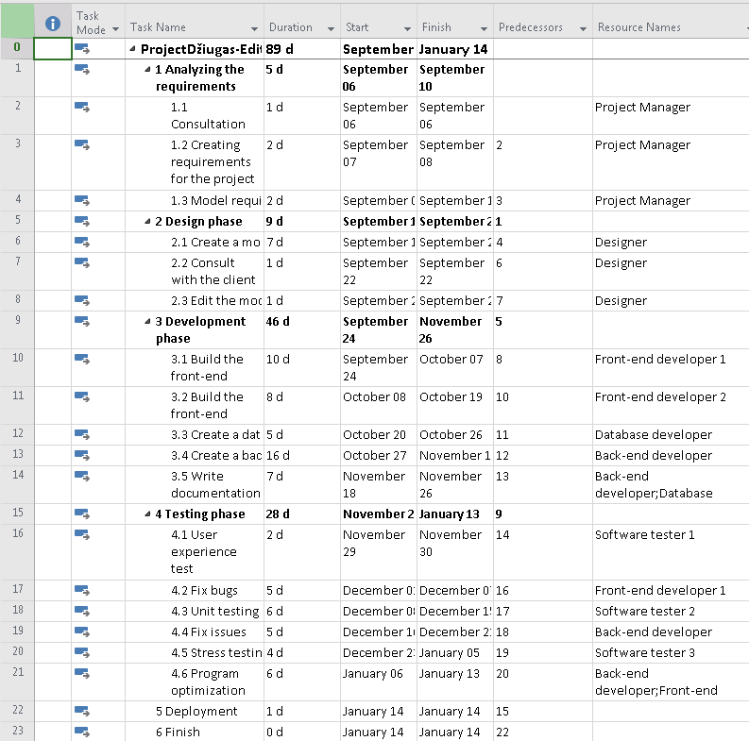

Figure 5 - project tasks with resources

## **Project schedule**

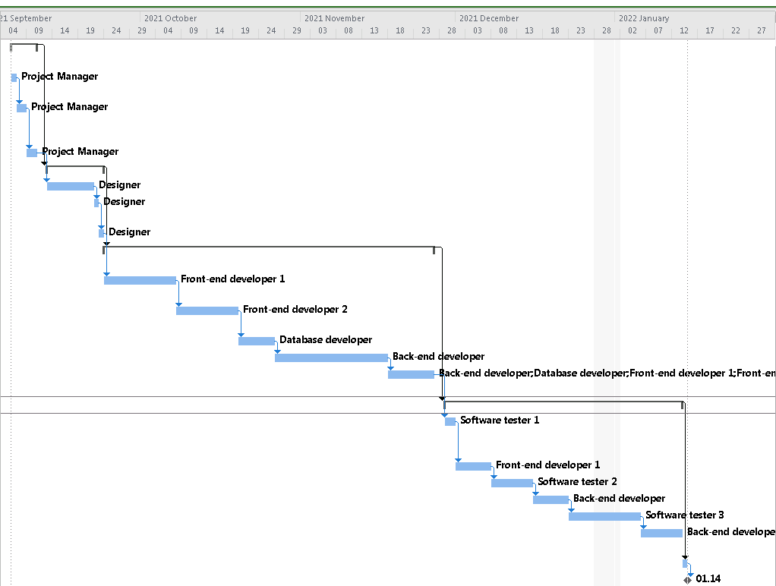

## **Project budget**

Project budget : 15,244€